
Green University of Bangladesh
Department of Computer Science and Engineering (CSE)
Faculty of Sciences and Engineering
Semester: (Fall, Year:2024), B.Sc. in CSE (Day)

Lab Report NO # 09
Course Title: Engineering Drawing
Course Code: CSE-208 Section: 221-D2

Lab Experiment Name: Familiarization with AutoCAD 3D Drawing
and Tools

Student Details

Name |  | ID
1. | Md.Fahad Nakib | 221902149

Lab Date : 26-12-23
Submission Date : 12-01-24
Course Teacher’s Name : Md Naimul Pathan

Lab Report Status
Marks: ………………………………… Signature:.....................
Comments:.............................................. Date:..............................

- TITLE OF THE LAB EXPERIMENT
Familiarization with AutoCAD 3D Drawing and Tools.

2. OBJECTIVES
- To gain the basic knowledge of 3D modeling.
- To implement the skills to develop basic 3D drawings.

3. TOOLS AND TECHNOLOGIES

1. line:
Line command draws a straight line from one point to another.
Shortcut Key: L
2. Circle:
Circle helps us to draw a circle. We can draw circle in many ways like using radius, diameter, tan-tan radius, etc.
Shortcut Key: C
3. Trim:
It is used for cutting unwanted line and edges.
Shortcut Key: Tr
4. Press pull:
The Press pull command in AutoCAD 3D is used to create an area formed by the closed boundary. It is used to pull an enclosed boundary. It can also be used to create a 3D solid in case of the selected circle or interior of the bounded area. The objects, such as arc, can be used to create a 3D surface.
5. Copy edge:
Using this command we can create another edge in particular distance.

4. IMPLEMENTATION

- Draw a rectangle and make two circle at one end and trim unnecessary lines and press pull half in one side and another half in opposite side.

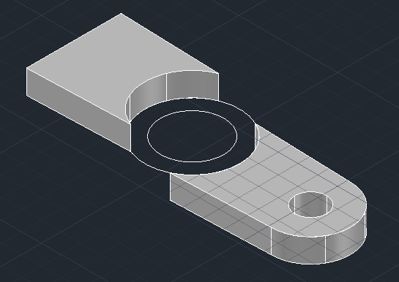
Figure: 01

- Using press pull command create shape of the circle and a box in the back.

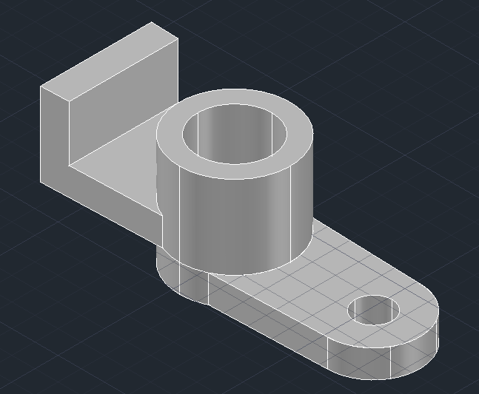
Figure: 02

- Create two circle in the back side box.

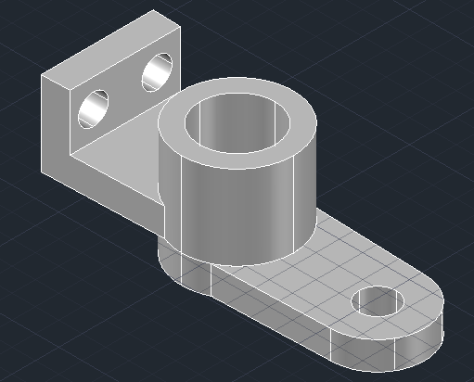
Figure : 03

- Creating middle box from the current shape.

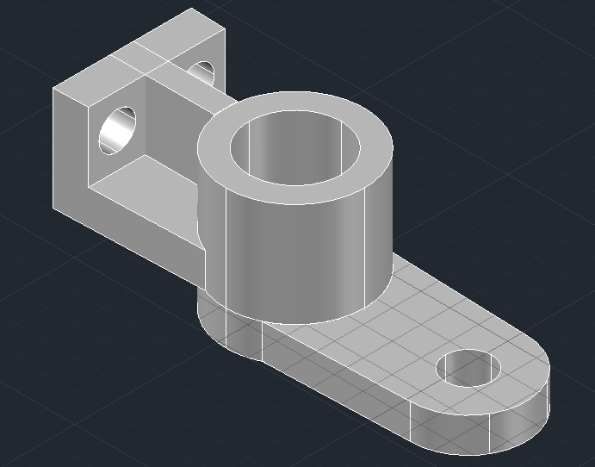
Figure : 04

- Create triangle shape and place it on the main figure.

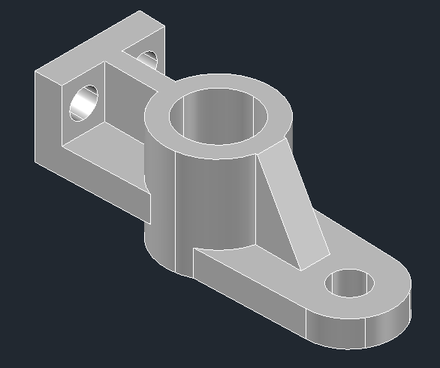

Figure: 05

6. FINAL OUTPUT

Figure: 10

7. ANALYSIS AND DISCUSSION
- This experiment helps us to learn about basic Auto Cad operations such as create press pull, move, copy, lines, circle, rectangle, etc.
- In this experiment I was facing some trouble while creating middle circle and press pull to the main figure.
- By this experiment we obtain the knowledge about 3D drawing technique and we can implement these tools to implement real life object.

